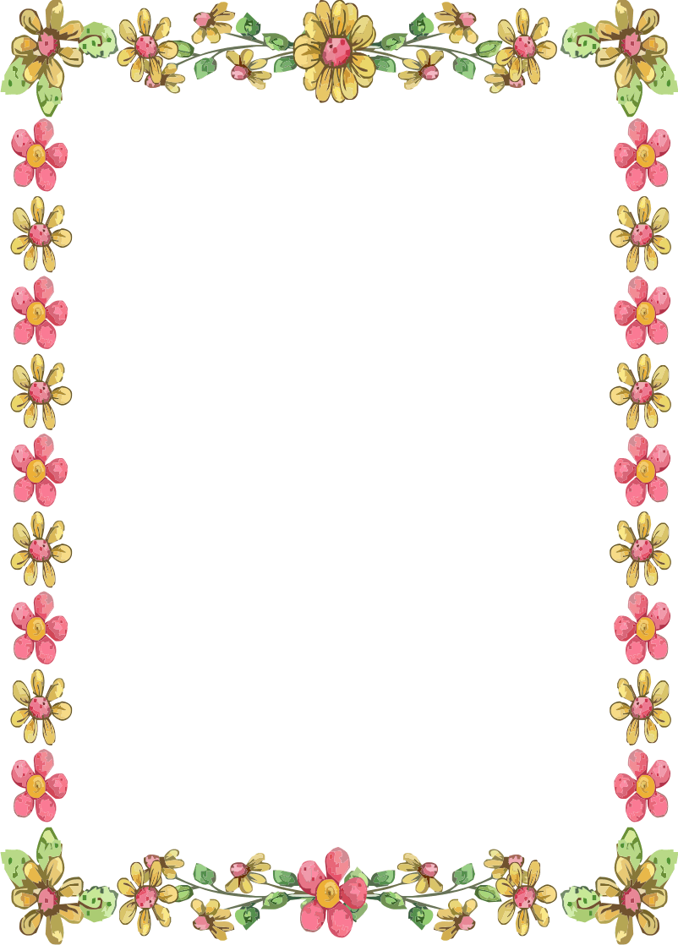

PRIDE IN PEMBURY 2019
ANNUAL HORTICULTURAL COMPETITION
Four categories:
Best allotment; best hanging basket/container;
best front garden and best community group
Send in the form below to the Parish Office, Lower Green Recreation Ground, Lower Green Road, Pembury, TN2 4DZ
deputy@pemburyparishcouncil.gov.uk

…………………………………………………………………………………………………………………………………….
Category of Entry (please tick)
Best front garden
Best Allotment
Best Hanging Basket/Container
Best Community Group
You can nominate anyone – even yourself!
Name of person nominating entry (if different) ……………………………………………
Address of entrant…………………………………………………………………………………………………
…………………………………………………………………………………………………………………………………….

The small print: The competition is not open to Parish Councillors or Parish Council employees or their close families. Garden entries must be within the boundaries of the
Civil parish. Judges will not be permitted to discuss entries. The judges’ decision is final and no correspondence will be entered into. The names of the winners will be published in the Pembury Village news and the winner of each category must be willing to participate in a publicity photo. Entry to the competition is deemed acceptance of these rules.

Closing date: 24 July 2019

